Chapter 1. The Machine Learning Landscape

What Is Machine Learning?
- Machine learning is giving the ability for computers to learn without being programmed.
- Programming computers to learn from data.
- Example: Spam filter

Why Use Machine Learning?
- Traditional Programming: image using traditional programming for identifying spam that would be difficult and complex for building a detection algorithm.
- Machine Learning: we can build a simple model to learn from data available. It will be more accurate, easier to maintain and more adaptable to change.
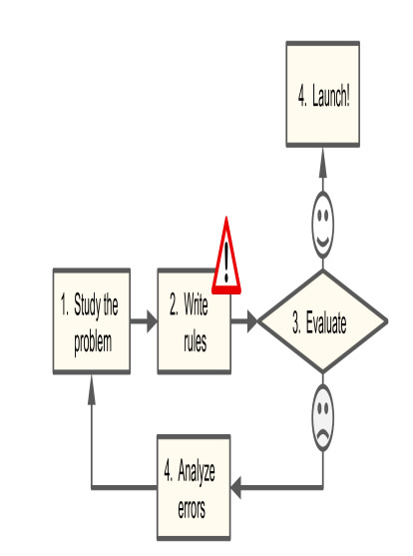
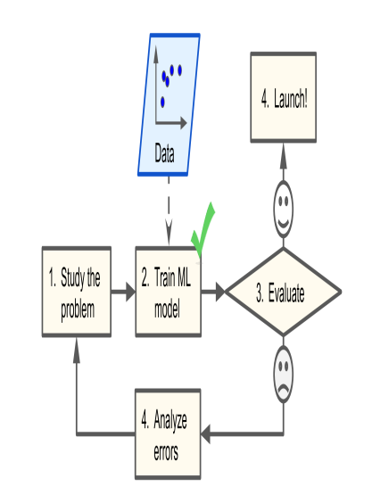
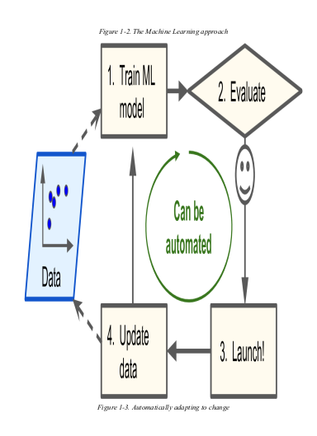
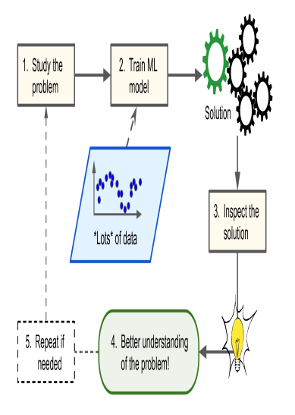

Types of Machine Learning Systems

Training Supervision
ML systems can be classified according to the amount and type of supervision they get during training.
- Supervised Learning: Requires labeled training data with desired solutions
- Unsupervised Learning: Uses unlabeled training data to discover hidden patterns.
- Semi-Supervised Learning: Utilizes a mix of labeled and unlabeled training data.
- Self-Supervised Learning: Generates labels from unlabeled data during training.
- Reinforcement Learning: Focuses on an agent's interaction with the environment through actions and rewards.

Batch versus Online Learning
Another criterion used to classify Machine Learning systems is whether or not the system can learn incrementally from a stream of incoming data.

Batch learning
Batch learning is a type of Machine Learning where the model is trained on the entire dataset before making predictions. This means that the model processes all the data points at once, calculating gradients and updating its parameters based on the entire dataset.

Online Learning
Online learning, also known as incremental learning, is a type of Machine Learning where the model is trained on data instances sequentially, either individually or in small batches. This allows the model to continuously learn and adapt to new data as it becomes available, without the need to retrain on the entire dataset.

Instance-Based Versus Model-Based Learning
One more way to categorize Machine Learning systems is by how they generalize. Most Machine Learning tasks are about making predictions. This means that given a number of training examples, the system needs to be able to make good predictions for (generalize to) examples it has never seen before. Having a good performance measure on the training data is good, but insufficient; the true goal is to perform well on new instances. There are two main approaches to generalization: instance-based learning and model-based learning.

Instance-based learning
Making predictions based on similarities and this requires a measure of similarity. the system learns the examples by heart, then generalizes to new cases by using a similarity measure to compare them to the learned examples (or a subset of them).

Model-based learning
Making predictions based on a model that captures the underlying relationships between input features and labels. you need to specify a performance measure. You can either define a utility function (or fitness function) that measures how good your model is, or you can define a cost function that measures how bad it is.

Main Challenges of Machine Learning

Insufficient Quantity of Training Data
Most Machine Learning algorithms require a large amount of training data to learn effectively. For complex tasks like image or speech recognition, millions of examples may be needed.

Non representative Training Data
Representative training data accurately reflects the distribution and characteristics of the population or phenomenon that the Machine Learning model is intended to generalize to. It should encompass the full range of possible input values, including rare or extreme cases, and accurately reflect the relationships between different features. This can’t be achieved if there is sampling noise or sampling bias.

Poor-Quality Data
Poor-quality data refers to data that contains errors, inconsistencies, outliers, or noise. This can include missing values, incorrect labels, duplicate entries, and irrelevant or redundant features. It will make it difficult for the model to capture underlying patterns.

Irrelevant Features
The data contains data features that are not important in training the model. These features don’t capture the underlying patterns in the data.

Over fitting the Training Data
The model performs well on the training data but don’t generalize well.

Under fitting the Training Data
It occurs when your model is too simple to learn the underlying structure of the data.

Testing and Validating
The only way to know how well a model will generalize to new cases is to actually try it out on new cases. One way to do that is to put your model in production and monitor how well it performs. This works well, but if your model is horribly bad, your users will complain—not the best idea. A better option is to split your data into two sets: the training set and the test set. As these names imply, you train your model using the training set, and you test it using the test set.

Hyper parameter Tuning and Model Selection
The problem is that you measured the generalization error multiple times on the test set, and you adapted the model and hyper parameters to produce the best model for that particular set. This means that the model is unlikely to perform as well on new data. To solve this problem, we can use :

Holdout Validation:
- Split the training set into training and validation sets.
- Train multiple models with various hyper parameters on the training set.
- Select the model that performs best on the validation set.
- Train the best model on the full training set (including the validation set).
- Evaluate the final model on the test set to estimate generalization error.
This solution usually works quite well. However, if the validation set is too small, then model evaluations will be imprecise: you may end up selecting a suboptimal model by mistake. Conversely, if the validation set is too large, then the remaining training set will be much smaller than the full training set. Why is this bad? Well, since the final model will be trained on the full training set, it is not ideal to compare candidate models trained on a much smaller training set. It would be like selecting the fastest sprinter to participate in a marathon.

Repeated Cross-Validation
Using many small validation sets. Each model is evaluated once per validation set after it is trained on the rest of the data. By averaging out all the evaluations of a model, you get a much more accurate measure of its performance. There is a drawback, however: the training time is multiplied by the number of validation sets.
Scenario:
Imagine you have a dataset of 1000 images and you want to compare the performance of two different image classification models: a convolutional neural network (CNN) and a support vector machine (SVM).
Steps:
- Divide the data into 10 folds (100 images per fold).
- For each fold:
    - Train the CNN and SVM models on the remaining 9 folds (900 images).
    - Evaluate the performance of each model on the held-out fold (100 images) using the accuracy metric.
    - Record the accuracy scores for both models.
- Repeat steps 2-3 for all 10 folds.
- Calculate the average accuracy for each model across all folds.

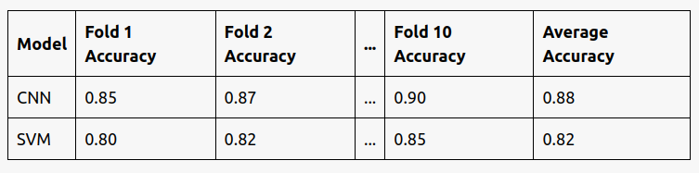
Data Mismatch

